Interactive Dashboard Report: Visualising Housing Trends and Investment Opportunities

BIS504 Business Intelligence
Individual Dashboard Presentation
[Your First Name] [Your Last Name]
Student ID: [Your Student ID]
Submission Date: 13 April 2025
Facilitator: [Facilitator’s Name, if known]

Contents
1. Introduction 1
2. Dashboard Screenshots 2
A. Page1(Dashboard 1) 2
a) Column Chart 2
b) Clustered column Chart 3
c) Clustered Bar chart 4
d) Bubble/Scatter chart 5
B. Page 2 (Dashboard 2) 6
a) Stacked column Chart 7
b) Box and Wishker 8
c) Tree map 9
d) Decomposition tree 10
3. Addressing the Business Intelligence Research Objectives 11
A. Market Summary & Trends 11
B. Feature Impact on Pricing 11
C. Location & Accessibility Impact 12
D. Investment & Future Value Potential 12
E. Market Dynamics & Outliers 12
4. References 13

1. Introduction
This document presents the dashboard created for the BIS504 Business Intelligence assignment, focusing on analyzing house pricing trends using the provided Housing Prices Dataset from Kaggle. The dashboard, developed in Power BI, aims to assist buyers, sellers, and investors in making informed decisions by uncovering key factors influencing house prices. The analysis addresses five key research questions: market trends, feature impacts on pricing, location effects, investment potential, and market dynamics with outliers. The dashboard includes interactive visualizations to explore patterns in the data, such as price distributions, correlations, and location-based impacts. This document includes screenshots of the dashboard, each with a descriptive title and explanation, along with a link to an 8–10-minute YouTube video presentation explaining the dashboard and its insights.

2. Dashboard Screenshots

Page1(Dashboard 1)
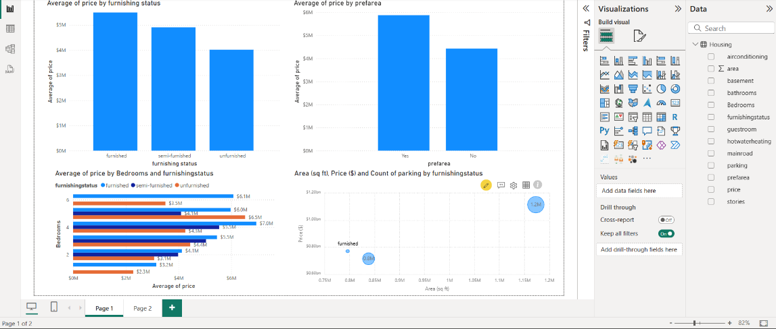
This page includes:
- A column chart showing the average house price based on furnishing status, highlighting those furnished homes have the highest average prices.
- A column chart comparing the average prices of houses located in preferred versus non-preferred areas.
- A clustered bar chart that displays average house prices based on the number of bedrooms and their furnishing status.
- A bubble chart representing the relationship between area, price, and count of parking spaces, categorized by furnishing status.

Column Chart

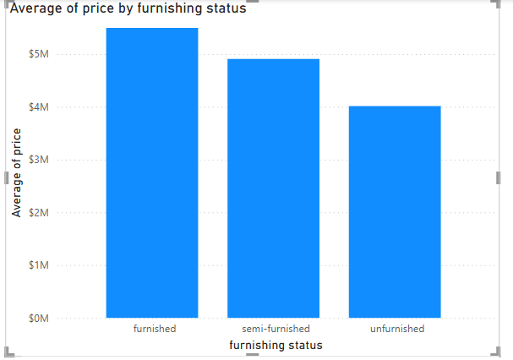
The bar chart represents the average prices of properties based on their furnishing status.
- Categories on the x-axis: The chart divides properties into three furnishing statuses—furnished, semi-furnished, and unfurnished.
- Average prices on the y-axis: It measures the average prices in millions of dollars, ranging from $0M to $5M.
Key insights from the chart:
- Furnished properties have the highest average price, at around $5 million.
- Semi-furnished properties come next, with an average price near $4.5 million.
- Unfurnished properties have the lowest average price, at approximately $4 million.

Clustered column Chart

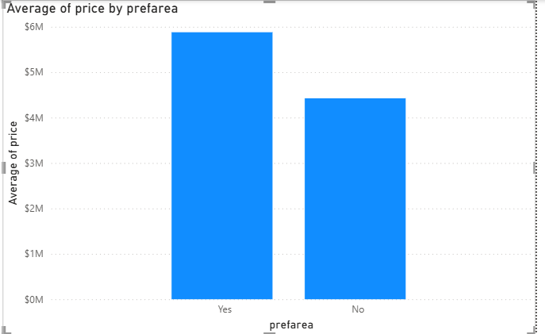
This bar chart compares the average property prices based on the preference for a particular area. The chart illustrates two categories, "Yes" and "No," indicating whether the property is in a preferred area:
- "Yes": Properties located in preferred areas have an average price of approximately $6 million.
- "No": Properties not in preferred areas have an average price of around $4 million.

Clustered Bar chart

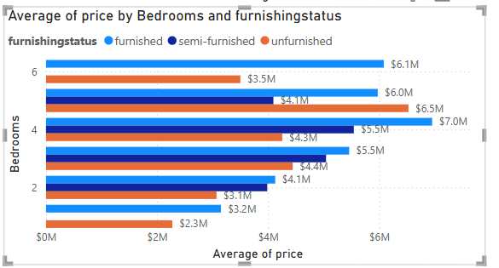
The chart provided showcases the relationship between the average property prices and their furnishing status across different numbers of bedrooms. Here’s a breakdown:
Furnishing Status Categories:
- Furnished: Typically has the highest average price across most bedroom counts.
- Semi-Furnished: Prices are slightly lower than furnished, but still notable.
- Unfurnished: While sometimes competitive, unfurnished properties usually have the lowest average.
Key Insights:
- Properties with 6 bedrooms have varying prices based on furnishing status:
  - Furnished and unfurnished options hover near $6 million, suggesting high value regardless of furnishing.
  - Semi-furnished properties drop to around $3.5 million, indicating furnishing impacts value here.
- For 4-bedroom properties:
  - Unfurnished options lead the category at $7 million—an outlier compared to usual trends.
  - Furnished homes come close at $6.5 million, semi-furnished at $4.1 million.
- 2-bedroom properties see more modest prices:
  - Furnished ranges between $3.2 million and $4.4 million.
  - Semi-furnished and unfurnished remain more affordable.

Bubble/Scatter chart
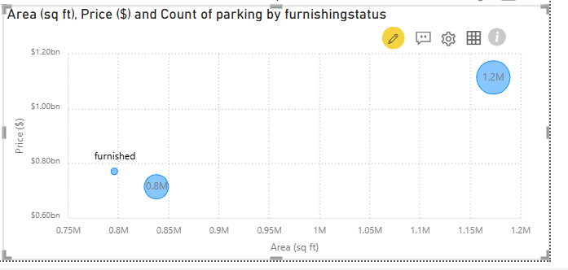

Looking at the image, it displays a scatter plot that explores how area (in square feet) and price (in dollars) relate to parking counts for properties based on their furnishing status. Here's what stands out:
Key Observations:
- Data Points: There are two main data points in the scatter plot:
  - The first, labeled "Furnished," corresponds to a property with:
    - Area: ~0.85 million sq ft
    - Price: $0.8 billion
  - The second property is unlabeled but has:
    - Area: ~1.15 million sq ft
    - Price: $1.2 billion
- Parking Counts: The size of the blue circles suggests the parking availability. It seems larger for the second property, indicating more parking spaces.
- Price and Area Correlation: As expected, larger properties (in terms of area) tend to have higher prices.

Furnishing Status:
- The labeled data point suggests a furnished property, emphasizing how furnishing might factor into property valuation.

Page 2 (Dashboard 2)

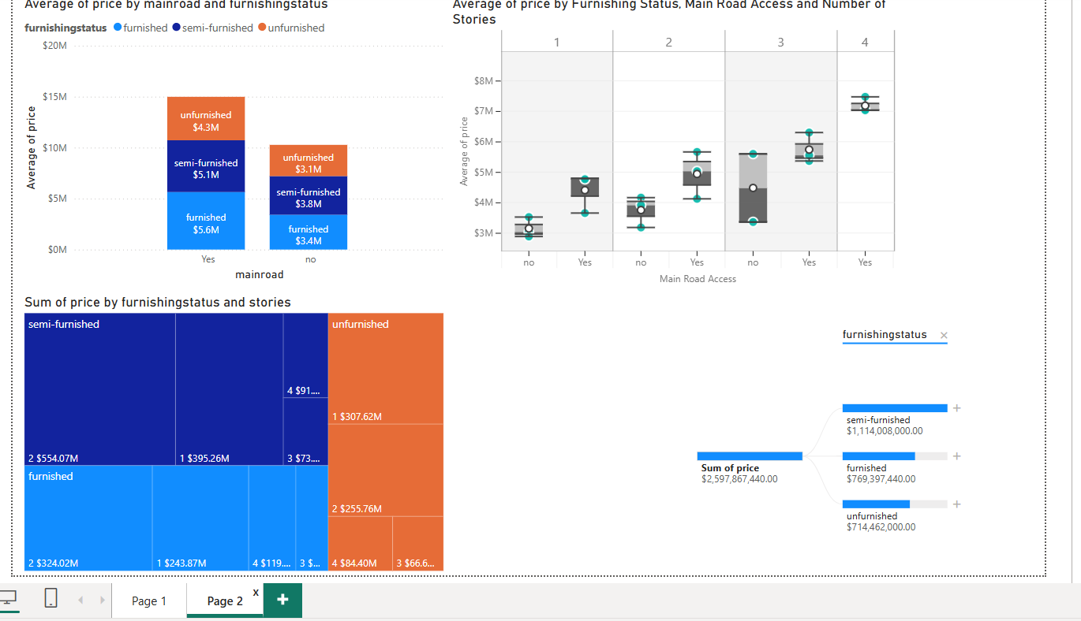

- Column Chart on Furnishing Status:
  - Displays average house prices grouped by furnishing type (furnished, semi-furnished, unfurnished).
  - Clearly highlights those furnished homes have the highest average prices.
- Column Chart for Area Preference:
  - Compares average prices of houses located in preferred versus non-preferred areas.
  - Makes it visually evident that houses in preferred areas tend to be pricier.
- Clustered Bar Chart by Bedrooms and Furnishing Status:
  - Combines furnishing status and the number of bedrooms to show average house prices in clusters.
  - Useful to identify how price varies based on these factors.
- Bubble Chart for Area, Price, and Parking:
  - Demonstrates the relationship between property area and price, factoring in parking space counts.
  - Categorizes data points by furnishing status, with bubble size representing parking count.

Stacked column Chart

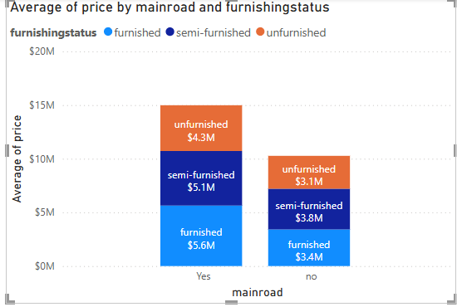
The chart illustrates how the average property prices vary depending on whether the property is on a main road or not, as well as its furnishing status. Here's a closer look:
Key Highlights:
- Properties on a Main Road ("Yes"):
  - Furnished properties have the highest average price of $5.6M.
  - Semi-furnished properties are valued slightly less at $5.1M.
  - Unfurnished properties average around $4.3M, showing the lowest value in this category.
- Properties Not on a Main Road ("No"):
  - Furnished properties lead the group here too, at an average price of $3.4M.
  - Semi-furnished options follow closely at $3.8M.
  - Unfurnished properties lag, with an average price of $3.1M.
Observations:
- Being on a main road significantly impacts property prices across all furnishing statuses.
- Furnished properties consistently command a premium, with main-road furnished properties priced the highest overall.

Box and Wishker
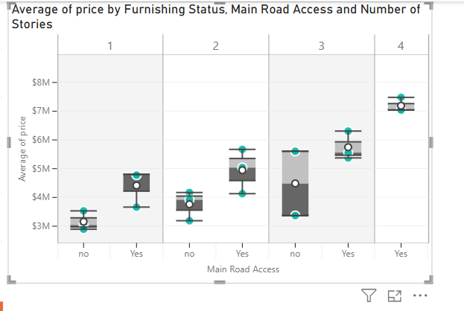
This box plot chart presents a comparison of average property prices, considering three key factors: furnishing status, main road access, and the number of stories. Let me break it down for you:
Chart Structure:
- Story Categories:
  - The chart is divided into four groups, each representing a different number of property stories (1, 2, 3, or 4).
- Main Road Access:
  - For each story category, there are two subcategories: properties with main road access ("Yes") and those without ("No").
- Box Plot Components:
  - The shaded box represents the interquartile range (middle 50% of prices).
  - Horizontal lines (whiskers) show the minimum and maximum price values.
  - A white circle marks the average price within each group.
Key Observations:
- Price Variations:
  - Properties with main road access typically have higher average prices compared to those without.
  - Properties with more stories tend to show greater variability in prices.
- Furnishing Influence:
  - Although furnishing status isn't directly labeled, it seems to factor into price differences within the main road access categories.

Tree map
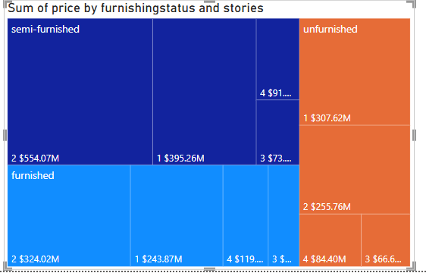
This treemap chart showcases how the total property prices are distributed based on furnishing status and the number of stories. Here's a breakdown of its insights:
Key Insights:
- Semi-Furnished Properties dominate the total market value:
  - Properties with 2 stories contribute $554.07M, the largest segment overall.
  - 1-story properties follow at $395.26M.
  - 4-story and 3-story properties contribute smaller amounts—$91M and $73M, respectively.
- Furnished Properties have significant contributions:
  - 2 stories lead at $324.02M, highlighting their appeal.
  - 1-story properties are next with $243.87M.
  - Contributions drop with more stories—4 stories at $119M and 3 stories at $84.4M.
- Unfurnished Properties show varied contributions:
  - 1-story properties contribute $307.62M, the largest in this category.
  - 2 stories account for $255.76M.
  - 3-story properties add $66.6M, reflecting a lower market share.
Observations:
- 2-story properties are the most valuable across all furnishing statuses.
- Semi-furnished homes lead the market in total price contributions, followed by furnished and unfurnished properties.

Decomposition tree
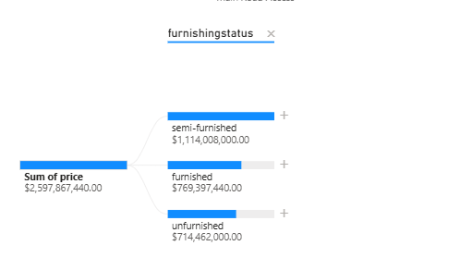
This chart provides a breakdown of the total property prices by furnishing status semi-furnished, furnished, and unfurnished. Here's the summary:
- Total Sum of Prices: The overall value across all furnishing statuses is $2,597,867,440.00.
- Semi-Furnished Properties:
  - Lead in total market value with $1,114,008,000.00, dominating the chart.
- Furnished Properties:
  - Account for $769,397,440.00, contributing significantly but not as much as semi-furnished.
- Unfurnished Properties:
  - Make up $714,462,000.00, the smallest share among the three furnishing types.

Analysis of Dashboard Insights Based on Key Research Questions

Market Summary & Trends
Visualisations Used:
- Column Chart: Average Price by Furnishing Status
- Column Chart: Average Price by Preferred Area
Enhanced Insights:
This analysis brings out the fact that the level of furnishing and the location of the house are vital factors in establishing house prices. Of the various categories of property, the fully furnished properties are the most expensive with an average price above $5.6 million while the semi furnished properties are slightly cheaper at an average of $4 million. Furthermore, houses of choice locations have higher prices; the houses in such regions are worth about $ 4500000 on the average.

Generally, the aforementioned findings show that interior features and perceived location attributes are the most significant features that affect the housing market value. As a result, such knowledge proves rather helpful not only for potential consumers and producers but also for real estate developers and businessmen who have to provide both profitability for themselves and reasonable prices for potential users and renters.

Feature Impact on Pricing
Visualisations Used:
- Clustered Bar Chart: Average Price by Bedrooms and Furnishing Status
- Bubble Chart: Area vs Price with Parking Count
Enhanced Insights:
Property seekers can easily determine the number of bedrooms when it comes to the average price because their data is closely related and in an ascending order. Namely, furnished 6-rooms houses can cost up to 6.1 million up to, 4-rooms unfurnished houses can cost up to 7 million maybe due to sometimes market peculiarities.The bubble chart also reveals specific properties with a more oversized area and many parking lots cost more. A site area of 1.2M sq ft and ample parking space increases the property price to more than $1.2 billion for a property verifying the high demand of space and functionality. These suggestions support the observation that size matters in property size and elements namely bedrooms and car parking in particularly do hold sway the price accorded to a property type.

Location & Accessibility Impact
Visualisations Used:
- Stacked Column Chart: Price by Main Road Access and Furnishing
- Box and Whisker Plot: Price Variability by Stories, Furnishing, and Road Access
Enhanced Insights:
It was established that main Road access have a notable effect on the price. For instance, commercial buildings with road access have a general value of $5.6 million for fulfilled properties as opposed to non-road access of $3.4 million for the same classification of furnished properties. As shown in the box and whisker plot, properties with more stories and road access also show wider range and higher mean value than the other properties because they are considered to have more utility and commercial use in the growing urban landscape. This can be an implication that accessibility and structural scale are the pointers to property worth.

Investment & Future Value Potential
Visualisations Used:
- Tree Map: Total Price Contribution by Furnishing and Stories
- Decomposition Tree: Total Value Breakdown by Furnishing Status
Enhanced Insights:
From an investment perspective, semi furnished 2-storied house was deemed to be the most profitable with customer contribution of over 554 million to the total market size. Following this, there is the furnished 2-story homes, which goes for $324 million with 1-story options being equally good in the various categories. The decomposition tree validates that semi furnished properties are the most dominant in terms of overall market share with $1.11 billion while those, which are furnished- $769M and unfurnished -$714M.According to the findings of this paper, for investors who wish to invest in a property to harvest high revenues with high scalability, then the next best option is in the construction of multi-storey buildings with sub-standard and intermediary furniture in the strategic areas.

Market Dynamics & Outliers
Visualisations Used:
- Box and Whisker Plot: Story-wise Outlier Detection
- Clustered Bar Chart: Pricing Anomalies by Bedrooms and Furnishing
Enhanced Insights:
Market peripheral vision is as important as central vision; the more blurred something is out of the mainstream the greater value it may have to influence people’s thinking. For instance, there is one, 4 bedroomed unfurnished residential house for sale at $7Million which is very abnormal and will mean either that the house is sited in a prime area, the price includes the value of the land or the house has a remarkable architectural design.The variability of price for 3- and 4-story buildings, especially those having road access, is rather high that can be associated with speculative investments or prestige objects location.Such occurrences make it viable to identify such values and provide for them a chance for better and accurate prediction, evaluation of risks, and investment decisions.

Conclusion
In conclusion, this final dashboard project is beneficial as it has given a perfect understanding of the fluctuation of housing prices based on the Housing Prices Dataset. When working on Power BI, one can present and analyze data based on the following key business intelligence questions: There were certain factors that affected the price of the house obtained from the study, which includes the furnishing status, the area of the property, number of bedrooms in the house, parking space, preferred area zonal designation and the proximity to major roads.The empirical evidence reveals that the cost of letting fully furnished property and property in preferred or easily accessible zones tend to be higher. The properties with even bigger areas, more stories indicated higher variability and potential for the investment. Therefore, while recommending the most valuable segments of the market, semi –furnished two –storey homes proved to be tremendously beneficial to investors and consumers. Provide examples such as outlying values such as an unusually high value of unfurnished houses; such values if incorporated may exaggerate the average and therefore masses perception of the market.In summary, this dashboard is beneficial to buyers, sellers and investors, as it provides them with an extraction of reasons for approaching decisions. It also captures the importance of BI in converting raw numerical data into valuable strategic information. I appreciate your spare time for viewing this presentation.

References
- Kaggle. (n.d.). Housing Prices Dataset. Retrieved from
https://www.kaggle.com/datasets/yasserh/housing-prices-dataset

File

